**Analysis of questionnaire results**

# Demographics

**Age**

Under 18 years old - 4 answers

Between 18 and 25 years old - 104

Between 26 and 40 years old - 45

Between 41 and 65 years old - 69

Over 65 years old - 9

**Gender**

Female - 111 answers

Male - 120

**Marital status**

Single - 154 answers

Married - 60

Divorced - 16

Widowed - 1

**Education level**

No education - 0 answers

Incomplete high school - 0

Complete high school - 17

Incomplete higher education - 88

Complete higher education - 46

Postgraduate - 74

Doctorate - 6

**Residence**

Águas Claras - 23 responses

Brazlândia - 0

Candangolândia -

Ceilândia - 7

Cruzeiro - 5

Gama - 16

Guará - 16

Itapuã - 0

Jardim Botânico - 27

Lago Norte - 5

Lago Sul - 5

Noroeste - 1

Núcleo Bandeirante - 2

Octogonal - 3

Paranoá - 3

Park Way - 14

Planaltina - 1

Plano Piloto - 41

Recanto das Emas - 1

Samambaia - 5

Santa Maria - 5

São Sebastião - 0

SCIA - 0

Sobradinho - 9

Sudoeste - 11

Taguatinga - 19

Varjão - 0

Altiplano Leste - 0

Outro - 12

**Family income**

Below 1 minimum wage - 2 answers

Between 1 and 2 minimum wages - 15

Between 2 and 5 minimum wages - 36

Between 5 and 10 minimum wages - 56

Between 10 and 20 minimum wages - 62

Above 20 minimum wages - 36

I prefer do not inform - 24

# Interest in sustainability, conscious disposal and recycling

**Interest in sustainability - scale**

1 (Not at all interested) - 4 responses

2 - 7

3 - 35

4- 68

5 (Very interested) - 117

**Frequency of seeking information about conscious disposal and recycling - scale**

1 ( Never) - 20 answers

2 - 39

3 - 77

4 - 59

5 (Daily) - 36

**Ease of accessing this type of information - scale**

1 (Very difficult) - 8 answers

2 - 27

3 - 57

4 - 64

5 (Very easy ) - 65

**Frequency of making more conscious consumer choices, such as preferring local products, organic products and/or products with recyclable/sustainable packaging - scale**

1 (Never looking) - 18 answers

2 - 40

3 - 68

4 - 66

5 (Always looking ) - 39

**Areas of sustainability that are of most interest**

Renewable energy sources - 145 answers

Waste management and recycling - 126

Energy efficiency - 119

Conscious consumption and waste reduction - 141

Sustainable development - 109

Environmental education and awareness - 100

Reduction of carbon emissions - 83

Circular economy and reuse of materials - 103

Green technologies and sustainable innovation - 111

Public policies and environmental legislation - 74

Others - 2

**Separating waste into recyclable and non-recyclable waste at home**

Yes, always - 137 answers

Sometimes - 66

No, never - 28

**Awareness of the existence of waste sorting centers in the region**

Yes, you are aware - 99 answers

No, you are not aware - 132

**How much are you involved in community projects that aim at sustainable practices - scale**

1 (Never gets involved) - 105 responses

2 - 59

3 - 35

4 - 19

5 (Always gets involved) - 13

**How familiar are you with the concept of economics green and its importance for sustainability - scale**

1 (Not familiar) - 32

2 - 32

3 - 59

4 - 65

5 (Very familiar) - 43

**What Brazilian government programs related to sustainability do you know or have you heard about**

Growth Acceleration Program (PAC) - 122

Incentive Program for Alternative Sources of Electricity (PROINFA) - 68

Program for Development in Renewable Energies and Energy Efficiency in Federal Institutions of Education (EnergIFE) - 32

Low Carbon Emission Agriculture Program (ABC) - 59

National Solid Waste Plan - 98

Green Grant - 38

ABC+ Plan (Agro+) - 18

None of the above - 45

None - 1

PEE - 1

Public calls - 1

Energy efficiency in buildings - 1

Green Eletron - 1

Sustainable Logistics Management Plan - 1

Public Administration Environmental Agenda (A3P) - 1

**What are the main challenges faced when trying to adopt sustainable practices in daily life**

Lack of access to environmentally friendly and/or sustainable products - 67

Higher costs associated with sustainable products and/or services - 173

Difficulty finding reliable information about sustainable practices - 55

Lack of motivation to change established habits - 63

Lack of adequate structure and/or resources for practices such as recycling and/or composting - 116

Lack of knowledge about the environmental consequences of certain behaviors - 15

Difficulty in finding sustainable alternatives for everyday products - 113

Concerns about the effectiveness or performance of sustainable products compared to conventional alternatives - 45

Has no challenges as it does not adopt sustainable practices - 1

None - 1

Domestic waste frequently rummaged by homeless people - 1

Little collection/non-existent collection for glass, electronics (batteries, batteries ,etc), medicines and chemicals - 1

## Websites and applications related to sustainability, conscious disposal and recycling

**Do you know and/or use websites or applications to obtain information about the region, if so which one/which ones**

No - 204 responses

GPS “Sustainable Criteria” Podcast - 1

Website 'Programando o Futuro” for electronic waste from the TJDFT Living Right Program - 1

SLU - 3

Reciclando o Futuro - 1

Reciclus - 1

Conscientious disposal - 1

Ecycle - 2

UNDP website in Brazil - 1

Integrated management of urban solid waste - 1

Website of the Secretariat for the Environment of the DF - 1

Inaturalist - 1

GCB - 1

CDC - 1

GOV website - 1

Center for sustainable practices CPS Jardim Botânico - 1

Jornal Métropoles - 1

Jornal G1 - 1

Jornal CorreioWEB - 1

Whatsapp groups - 1

Social networks - 2

Newspapers - 1

Google - 2

**Would you be interested in a website or app that provides information about reuse, recycling and sustainable practices focused on your region of residence**

Yes - 117 responses

Maybe - 107

No - 7

**What type of information would you like to find on this website or app**

Tips for sustainable practices in everyday life day - 171 responses

Nearby recycling points - 196

Disclosure of projects and initiatives on sustainability in your region - 147

Information on reuse and recycling - 150

Places to purchase sustainable products - 158

Statistics on waste in your region - 126

News on sustainability - 96

Official places to report - 1

Contacts of related bodies - 1

Places/stores/brands that exchange packaging for products (example: Natura and O Boticário) - 1

Gamification - 1

**What is the most effective content format to learn on this website or app**

Articles written - 111 responses

Infographics - 163

Educational videos - 130

Podcasts - 73

Lectures and/or meetings - 1

Newsletter - 1

News - 1

Gamification - 2

Daily tasks - 1

Knowledge trails - 1

**How much do you believe that the inclusion of a discussion forum on this website or application could contribute to strengthening interaction and engagement between users, providing a space to share experiences, ideas and tips from the region - scale**

1 (I don't believe) - 11

2 - 37

3 - 71

4 - 65

5 (I truly believe) - 48

**How much you believe that this website or application would facilitate the registration, search and evaluation of sustainable products and/or services in the region - scale**

1 (I don't believe) - 7

2 - 11

3 - 42

4 - 95

5 (I truly believe) - 77

**Preference to receive updates and/or notifications**

Push notifications - 82 responses

Emails - 54

Messages - 45

No preference - 43

Prefer not to receive - 3

Whatsapp - 2

**Interest in Sustainability x Age / Age x Education**

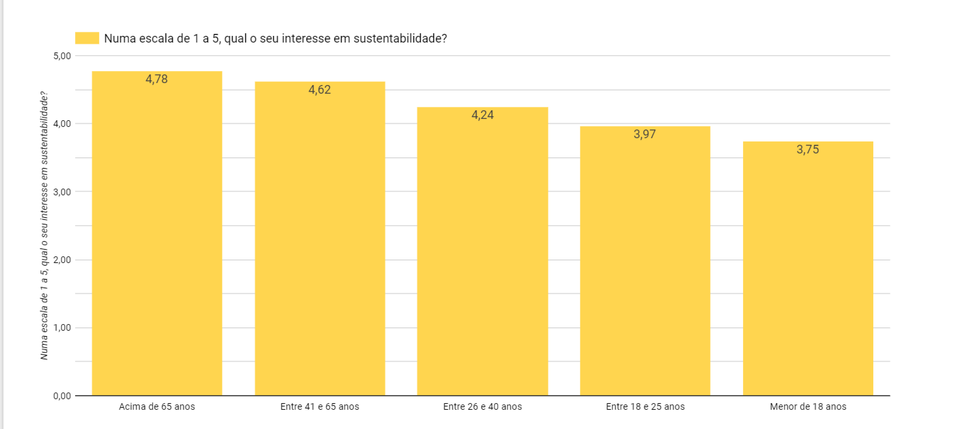

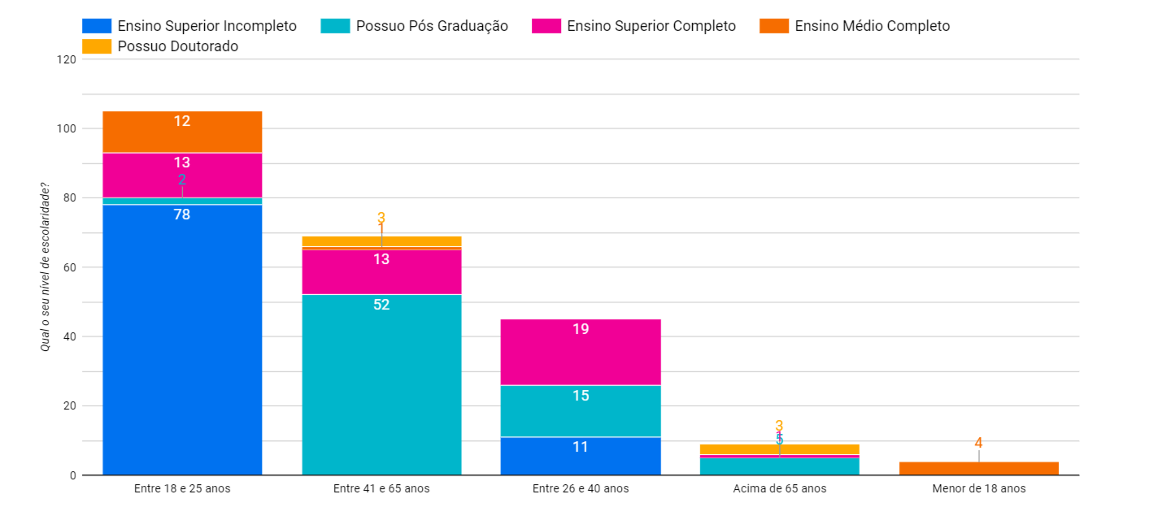

The older the age, the greater the average interest in sustainability. It is also possible to note that few people over 65 responded to the survey, so data from this age group is not as reliable. Most of the people who responded to the survey had more than completed high school (Only 12 people out of 232 answered completed high school. This represents 5.2% of the responses). This indicates that the HUB must be designed both for “lay” people who do not have much experience with technology and also for people who are not “lay” but do not have as much contact with technology.

**Notification system**

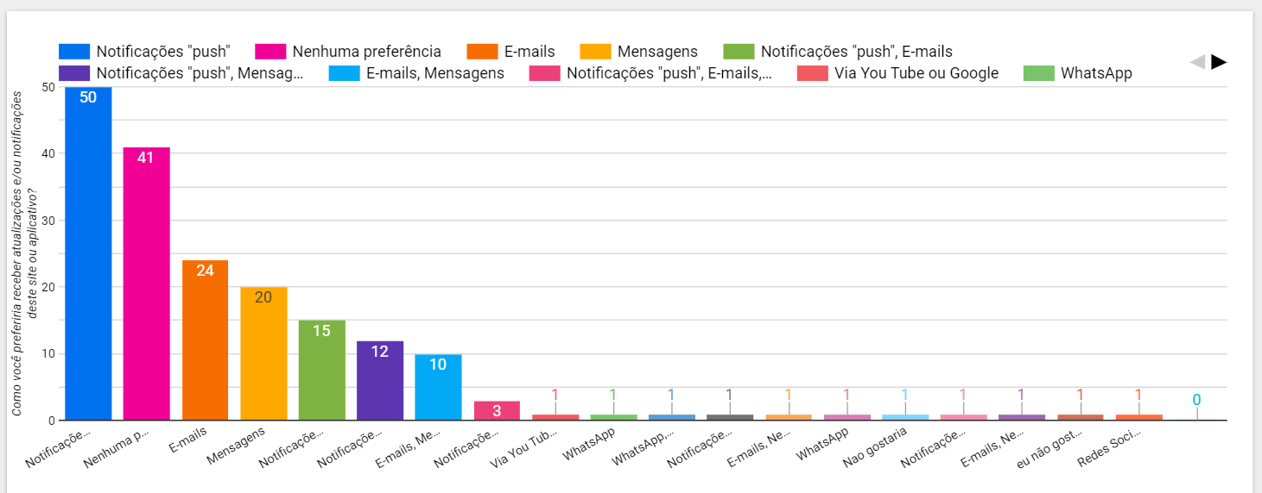

Unfortunately, several people did not respond to this part of the questionnaire. Among those who responded, “Push notifications” and “No preference” were the most voted by some margin. However, several people also voted for “messages”, “emails”, and their combinations with “Push notifications”. It makes sense to develop notifications in these main media and have an option for the user to choose how they want to receive notifications. There was no significant interest in “In-person Meetings”, “Whatsapp”, “Youtube and Google”, “Newsletter”, etc.

**Interest in “Discussion Forum”**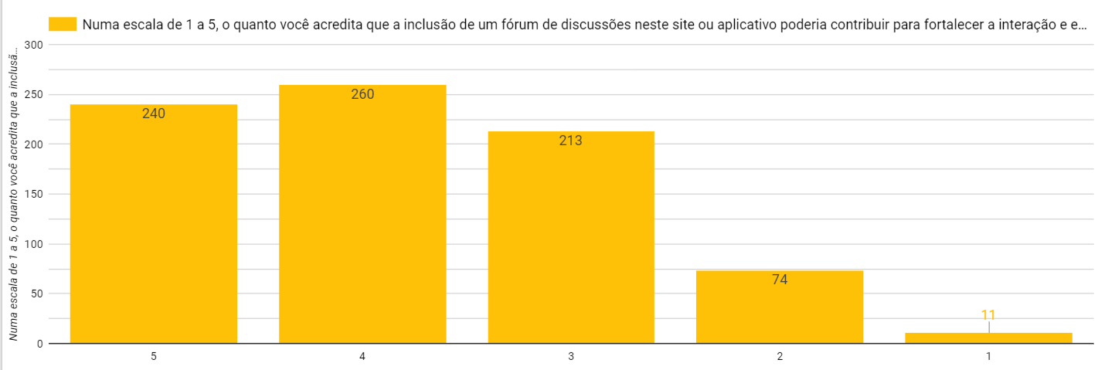

**62%** of survey participants voted for at least a 4, on a scale of 1 to 5. If we consider that a 3 is a “neutral” rating, the number of participants who believe that this forum could contribute at least a little to strengthening interaction and engagement between users, providing a space to share experiences, ideas and tips in their region rises to 89%.

**Family Income and Education x Challenges when adopting sustainable practices**

It was not possible to provide any simple visualization, but in short it was not possible to find any significant influence of Family Income and Education on the challenges when adopting sustainable practices. There is practically a consensus that the main problems are “Lack of access to ecological and/or sustainable products”, “Higher costs associated with sustainable products and/or services” (this is a clear winner), “Difficulty in finding sustainable alternatives for products for daily use” and “Lack of adequate structure and/or resources for practices such as recycling and/or composting”. In my view, all these difficulties can be resolved with the proposed marketplace.

**Gender x Frequency of searching for Sustainability information**

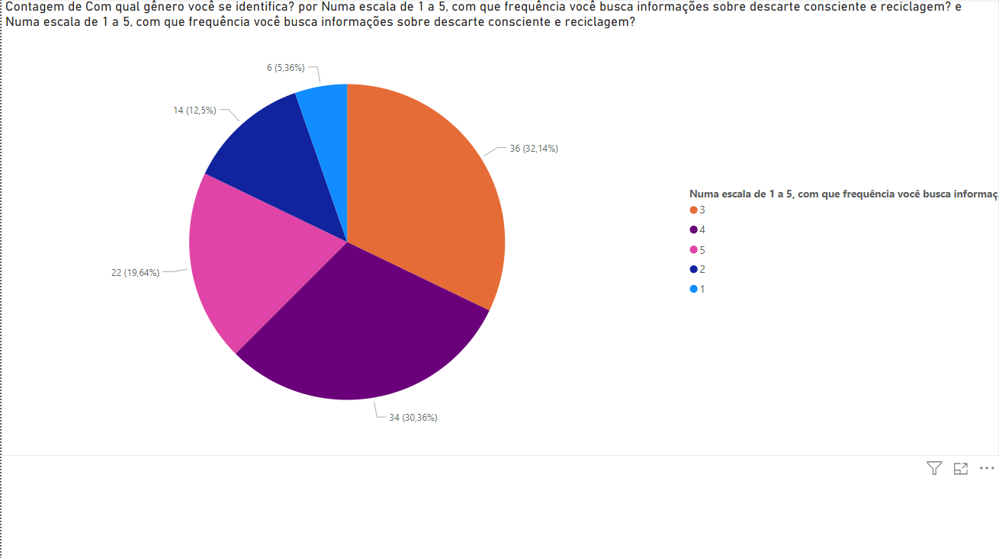

**82.14%** of women seek Sustainability information at a frequency greater than or equal to 3, on a scale of 1 to 5. When considering a frequency greater than or equal to 4, on a scale of 1 to 5, the percentage goes to 50% .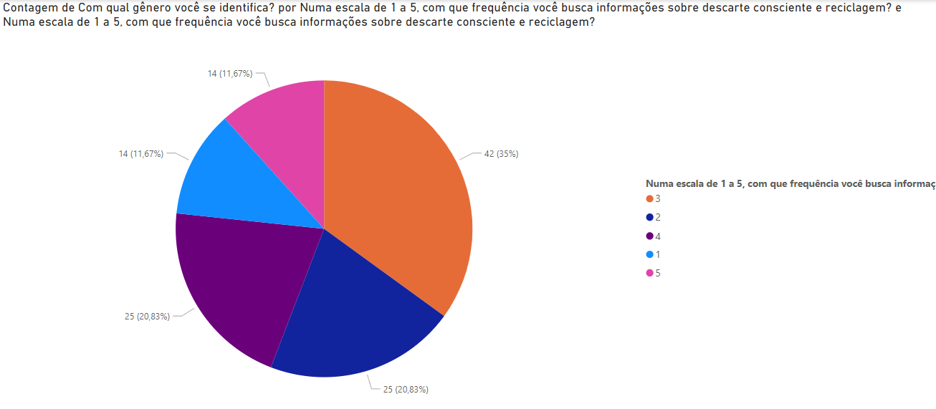

**67.5%** of men seek Sustainability information at a frequency greater than or equal to 3, on a scale of 1 to 5. When considering a frequency greater than or equal to 4, on a scale of 1 to 5, the percentage goes to 32, 5%.

Clearly, for females there is a relatively greater interest in sustainability information than for males.

**Knowledge about applications with regional information**

Few are aware of applications with regional information

**Most effective content format**

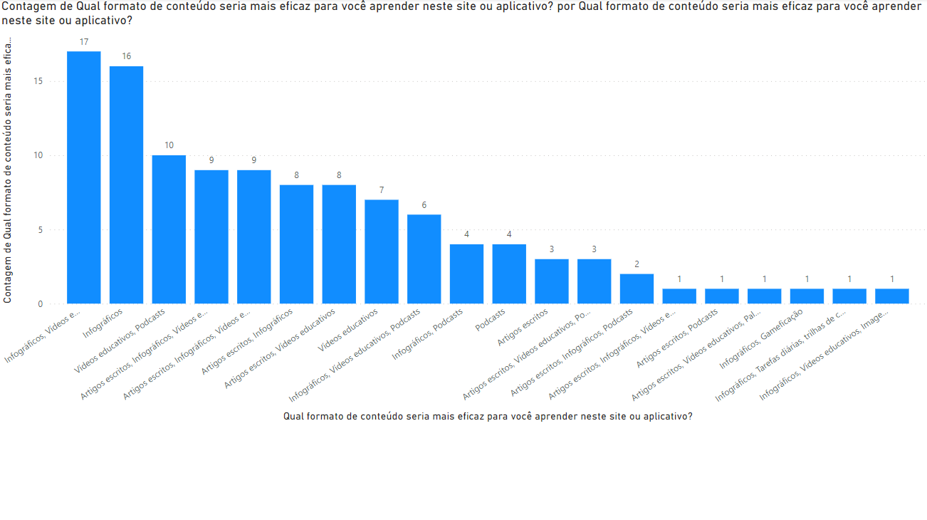

Written articles - 111 responses

Infographics - 163

Educational videos - 130

Podcasts - 73

Lectures and/or meetings - 1

Newsletter - 1

News - 1

Gamification - 2

Daily tasks - 1

Knowledge trails - 1

Written articles, infographics, educational videos and podcasts were the most demanded formats. The other formats did not have significant demand.

**Gender x Interest in a website or app that provides information about reuse, recycling and sustainable practices, especially focused on your region**

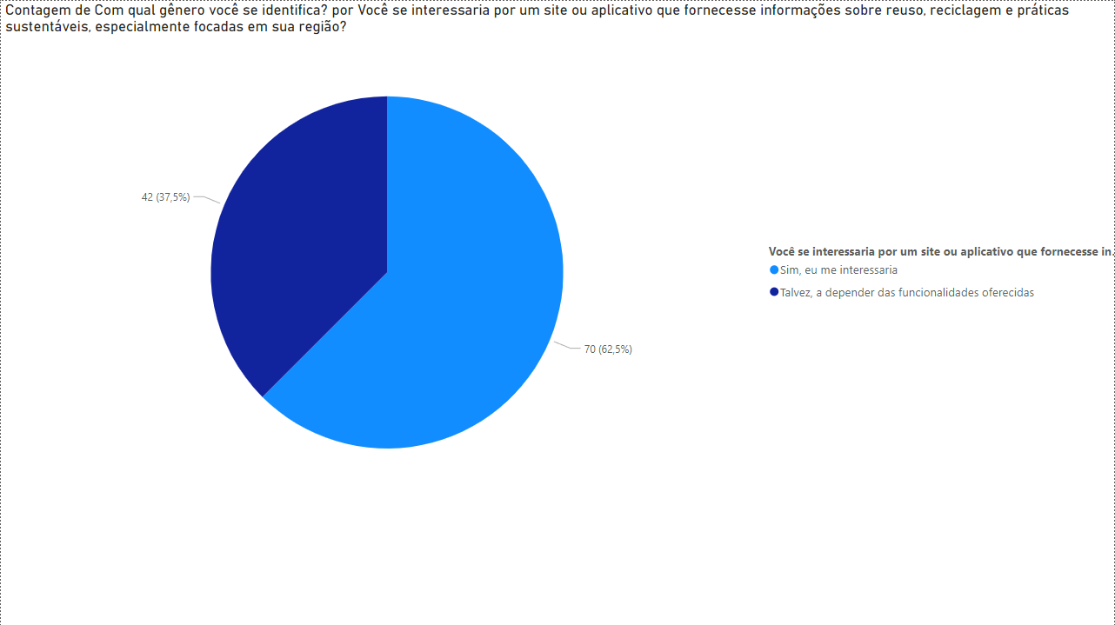

**62.5%** of women were interested in a website or application with the above proposal, while **37.5%** might be interested (depending on the features)

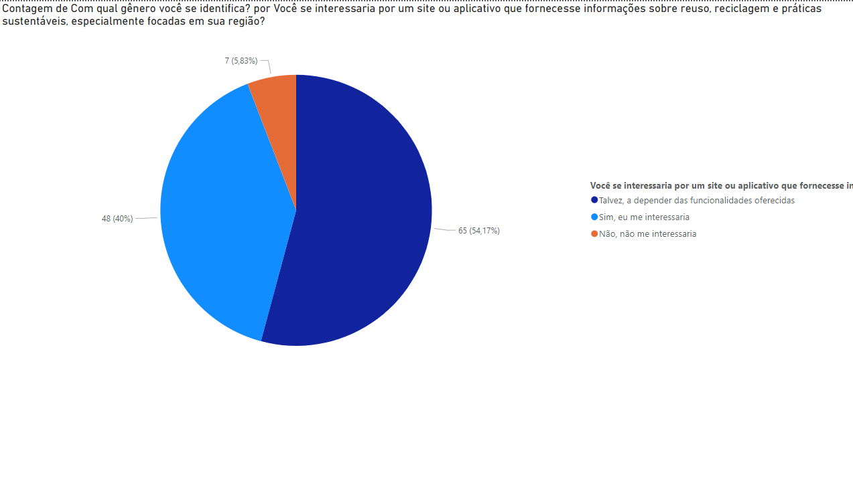

**54.17%** of men were interested in a website or application with the above proposal, while **40%** would perhaps be interested (depending on the features) and **5.83%** would not be interested.

Once again, it is clear that women's interest is greater than men's in sustainability

**Familiarity with the concept of Green Economy and its importance for sustainability**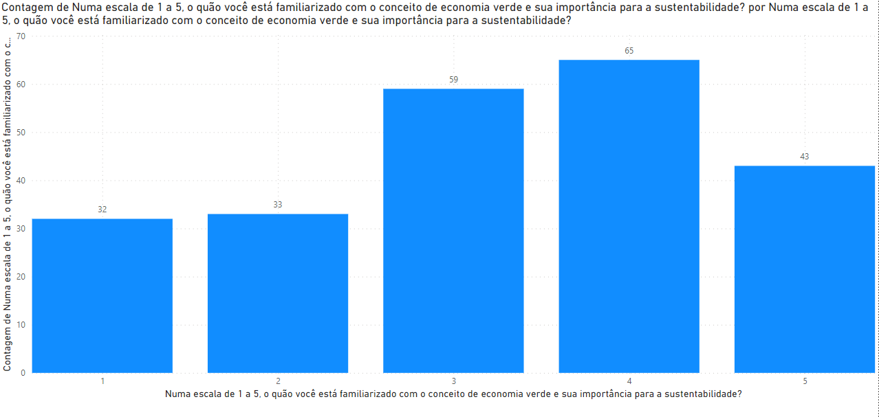

Around **28%** of people who voted are aware of the Green Economy and its importance for sustainability less than or equal to 2. This indicates that it would be important to explain the term in the hub so that the concept does not become unknown